Họ tên : Lê Bảo Khánh

MSSV : 1911363

Lớp : L01

**LAB 4b**

(Using dhcp-ethereal-trace-1 trace file)

**Question 1**: Are DHCP messages sent over UDP or TCP?

**ANSWER:**

DHCP messages are sent over UDP (User Datagram Protocol)

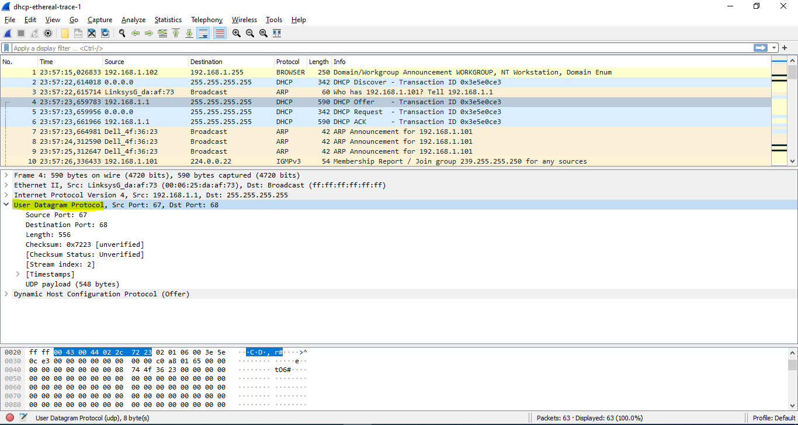

**Question 2:** Draw a timing datagram illustrating the sequence of the first four-packet Discover/Offer/Request/ACK DHCP exchange between the client and server. For each packet, indicated the source and destination port numbers. Are the port numbers the same as in the example given in this lab assignment?

**ANSWER:**

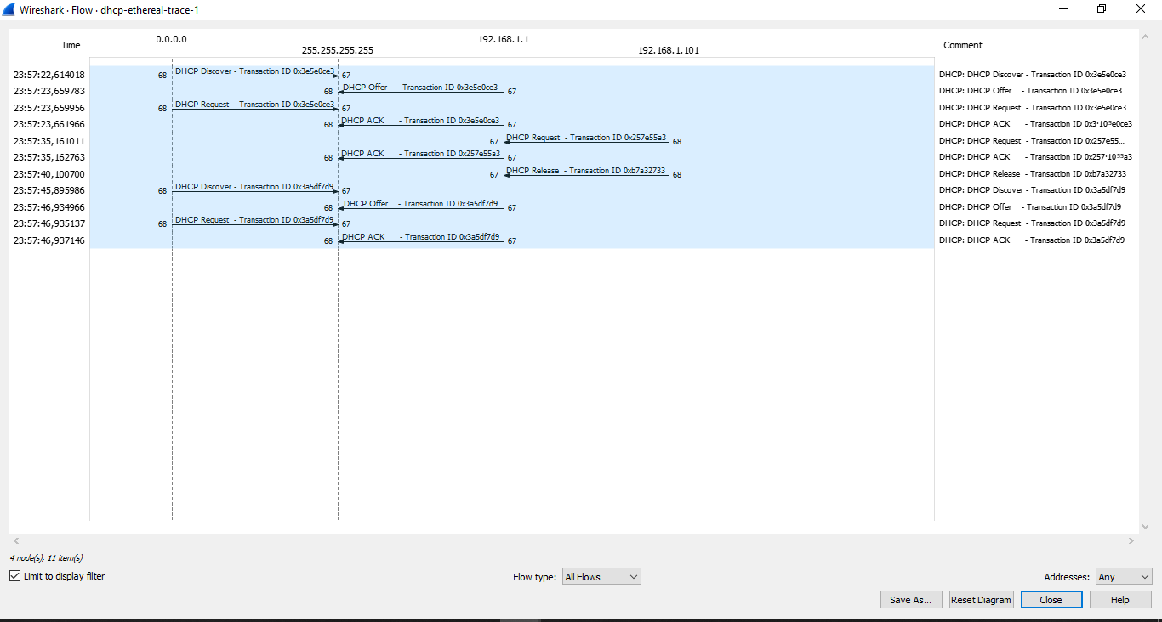

The port numbers are the same as the example given in this lab assignment

**(67 and 68)**

(The ports are displayed on the diagram for each packet:

source port ------------(Packet)---------> destination port)

**Question 3:** What is the link-layer (e.g., Ethernet) address of your host?

**ANSWER:**

The link-layer address of my host is **(00:08:74:4f:36:23)**

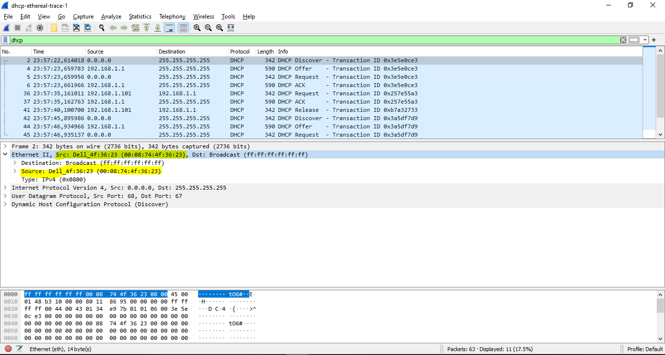

**Question 4:** What values in the DHCP discover message differentiate this message from the DHCP request message?

**ANSWER:**

The values which differentiate the Discover message from the Request message:

**Option: (53) DHCP Message Type**

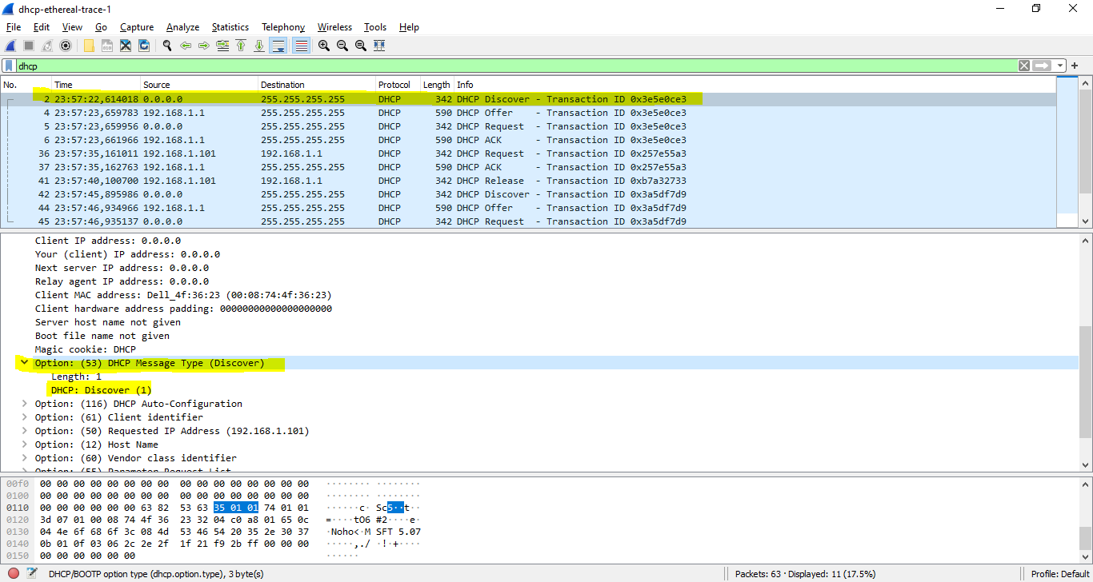

Vs

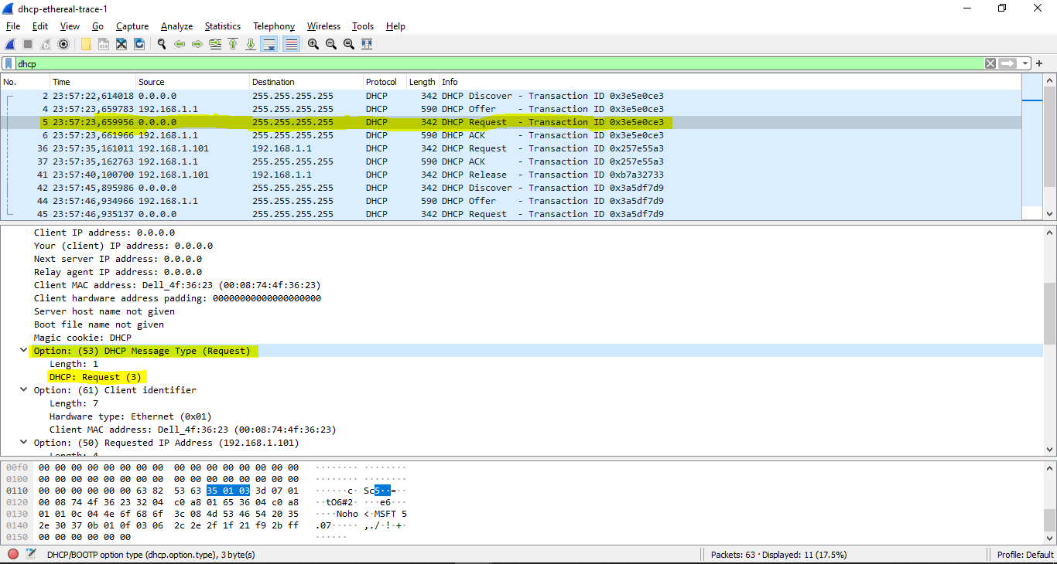

**Question 5**: What is the value of the Transaction-ID in each of the first four  
(Discover/Offer/Request/ACK) DHCP messages? What are the values of the  
Transaction-ID in the second set (Request/ACK) set of DHCP messages? What is  
the purpose of the Transaction-ID field?

**ANSWER:**

The value of the transaction id in the first four DHCP messages is: **[Transaction ID: 0x3e5e0ce3]**

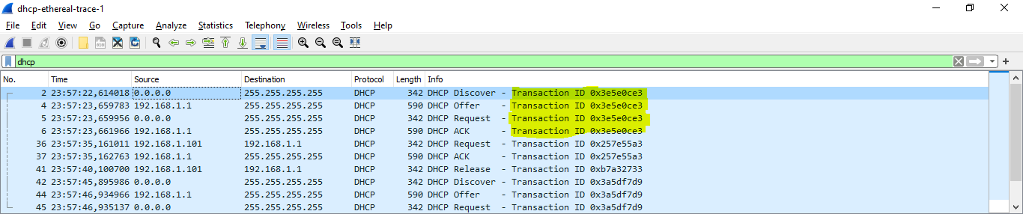

The value of the transaction id in the second set is **[Transaction ID: 0x257e55a3]**

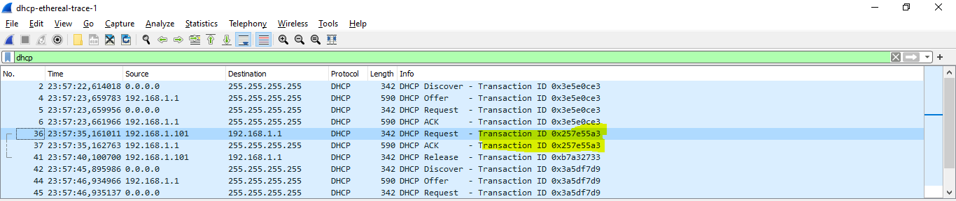

=> Purpose: The transaction ID is different so that the host can differentiate between different requests made by the user.

**Question 6:** A host uses DHCP to obtain an IP address, among other things. But a host’s IP address is not confirmed until the end of the four-message exchange! If the IP address is not set until the end of the four-message exchange, then what values are used in the IP datagrams in the four-message exchange? For each of the four DHCP messages (Discover/Offer/Request/ACK DHCP), indicate the source and destination IP addresses that are carried in the encapsulating IP datagram.

**ANSWER:**

The DCHP client and server both use **255.255.255.255** as the destination address. The client uses source IP address **0.0.0.0**, while the server uses its actual IP address as the source.

Discover Src – **0.0.0.0**, Dst – **255.255.255.255**

Offer Src – **192.168.1.1**, Dst – **255.255.255.255**

Request Src – **0.0.0.0**, Dst – **255.255.255.255**

ACK DHCP – **192.168.1.1**, Dst – **255.255.255.255**

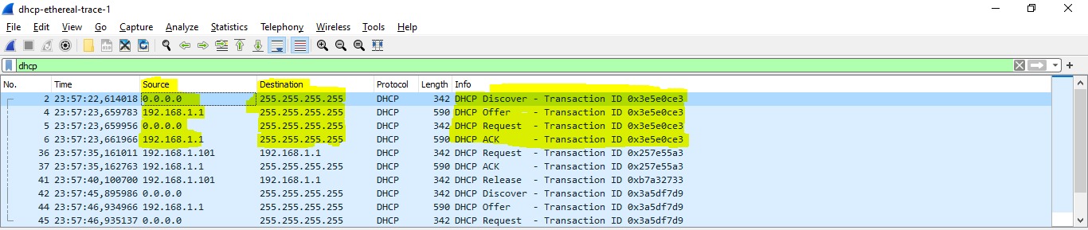

**Question 7:** What is the IP address of your DHCP server?

**ANSWER:**

The IP address of my DHCP server is: **192.168.1.1**

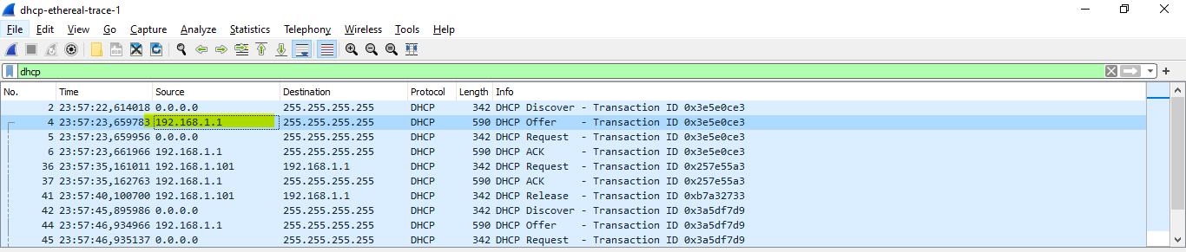

**Question 8:** What IP address is the DHCP server offering to your host in the DHCP Offer message? Indicate which DHCP message contains the offered DHCP address.

**ANSWER:**

The IP address in which the DHCP server is offering to my host in the DHCP Offer message is **192.168.1.101**

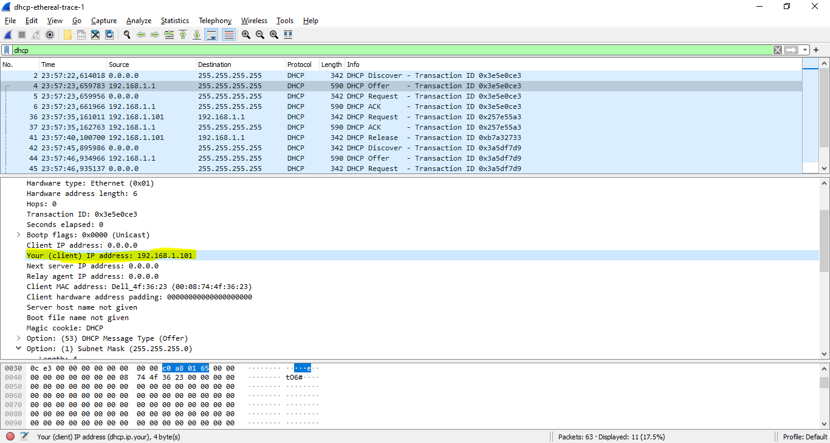

**Question 9**: In the example screenshot in this assignment, there is no relay agent between the host and the DHCP server. What values in the trace indicate the absence of a relay agent? Is there a relay agent in your experiment? If so what is the IP address of the agent?

**ANSWER:**

The IP is **0.0.0.0** => There is no relay agent.

If there were an IP there then we could give values in the trace

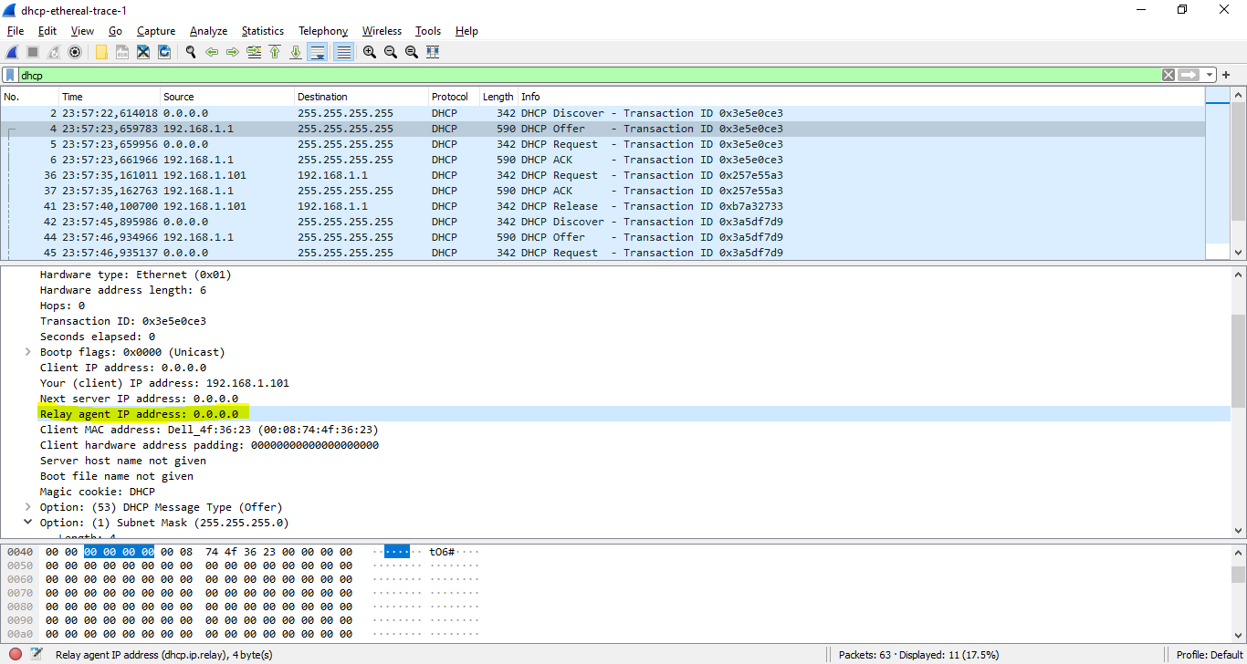

**Question 10:** Explain the purpose of the router and subnet mask lines in the DHCP offer message.

**ANSWER:**

The router line indicates to the client what its default gateway should be.

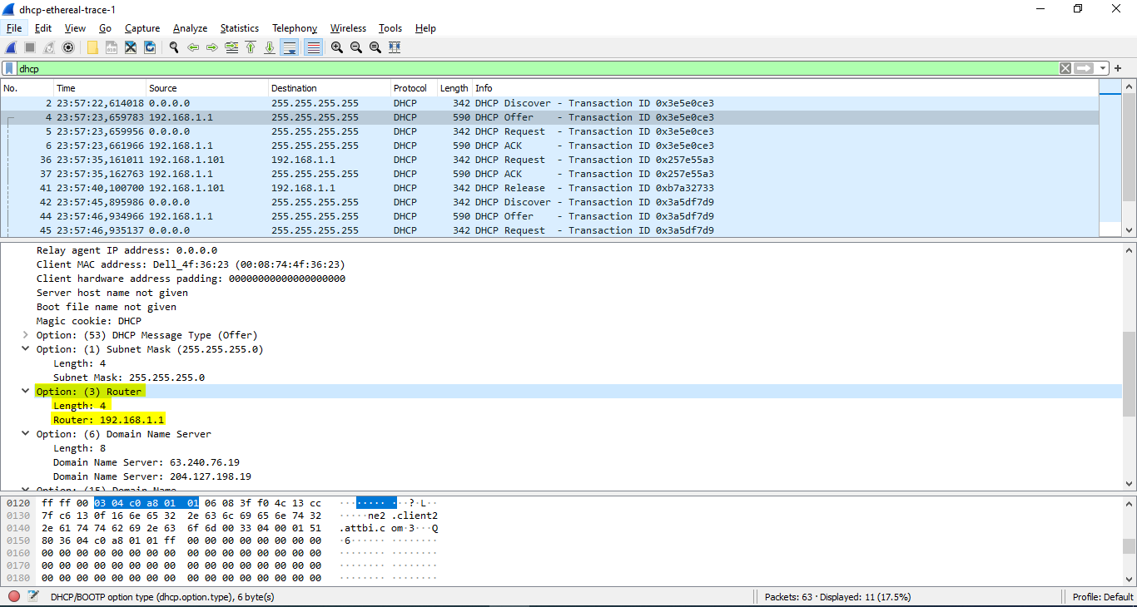

The subnet mask line tells the client which subnet mask it should use.

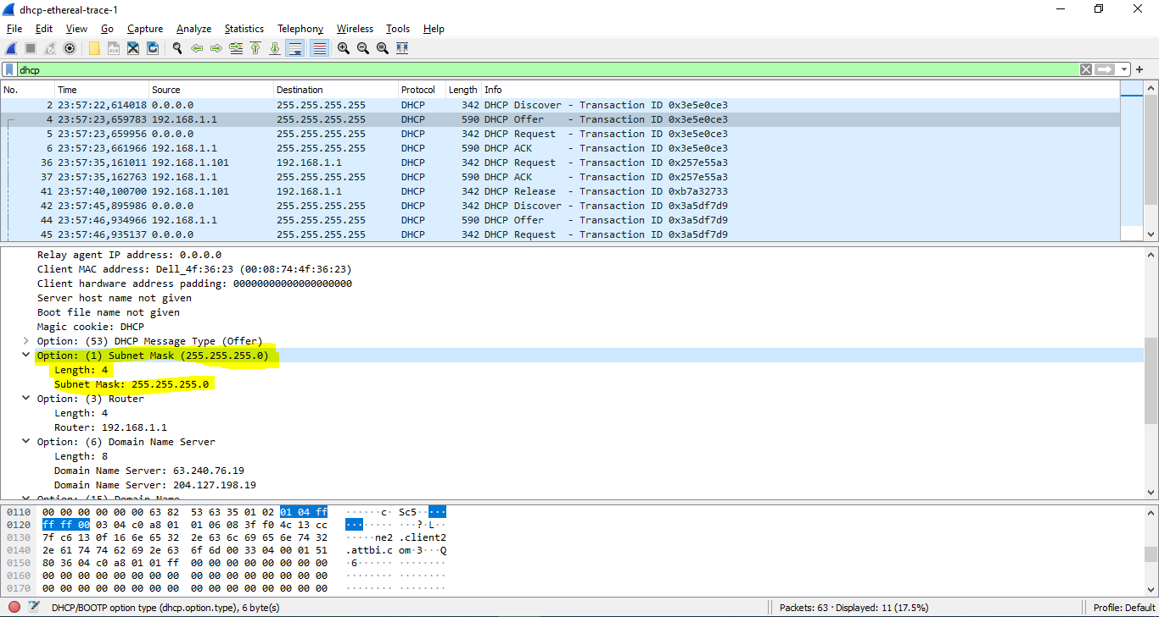

**Question 11:** In the DHCP trace file noted in footnote 2, the DHCP server offers a specific IP address to the client (see also question 8. above). In the client’s response to the first server OFFER message, does the client accept this IP address? Where in the client’s RESPONSE is the client’s requested address?

**ANSWER:**

In my experiment, the client accept this IP address

The client requests the offered IP address in the DHCP Request message.

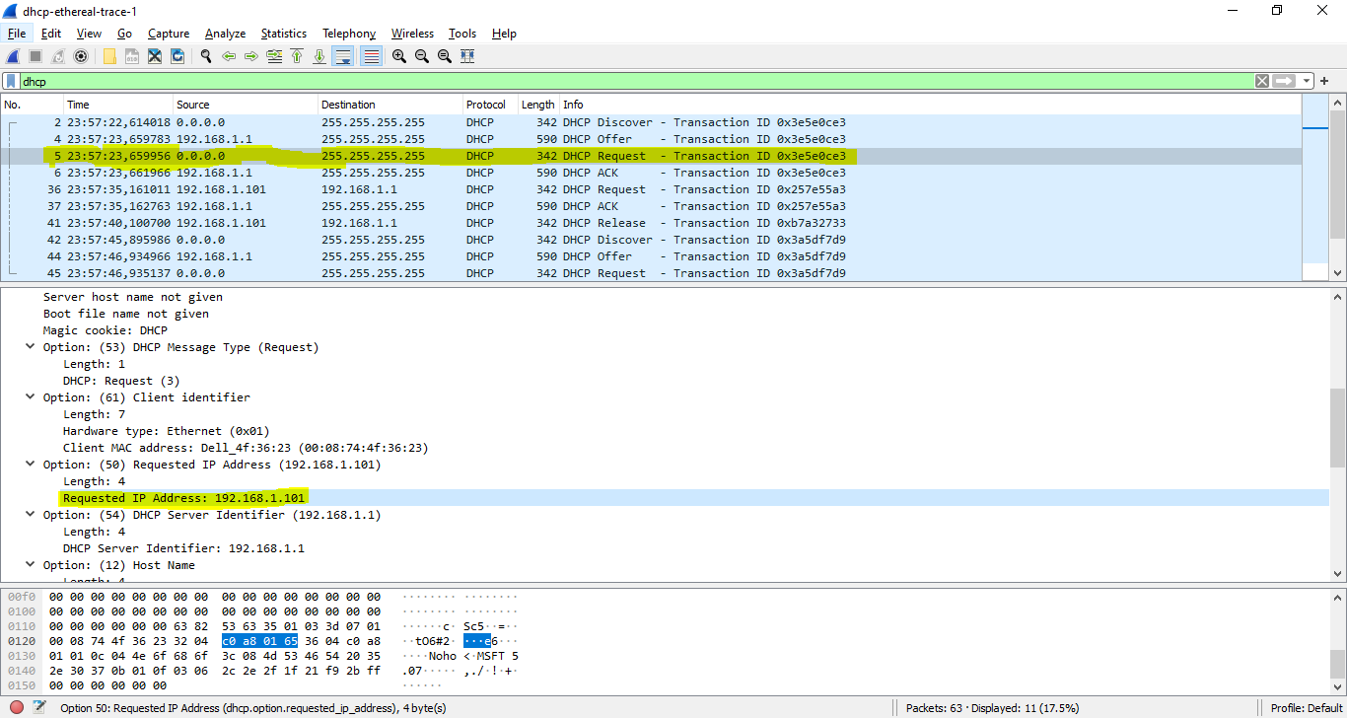

**Question 12:** Explain the purpose of the lease time. How long is the lease time in your experiment?

**ANSWER:**

The purpose of lease time: tell the client how long they can use the specific IP address assigned by the server before they will have to be assigned a new one.

The lease time in my experiment is **[IP Address Lease Time: (86400s) 1 day]**

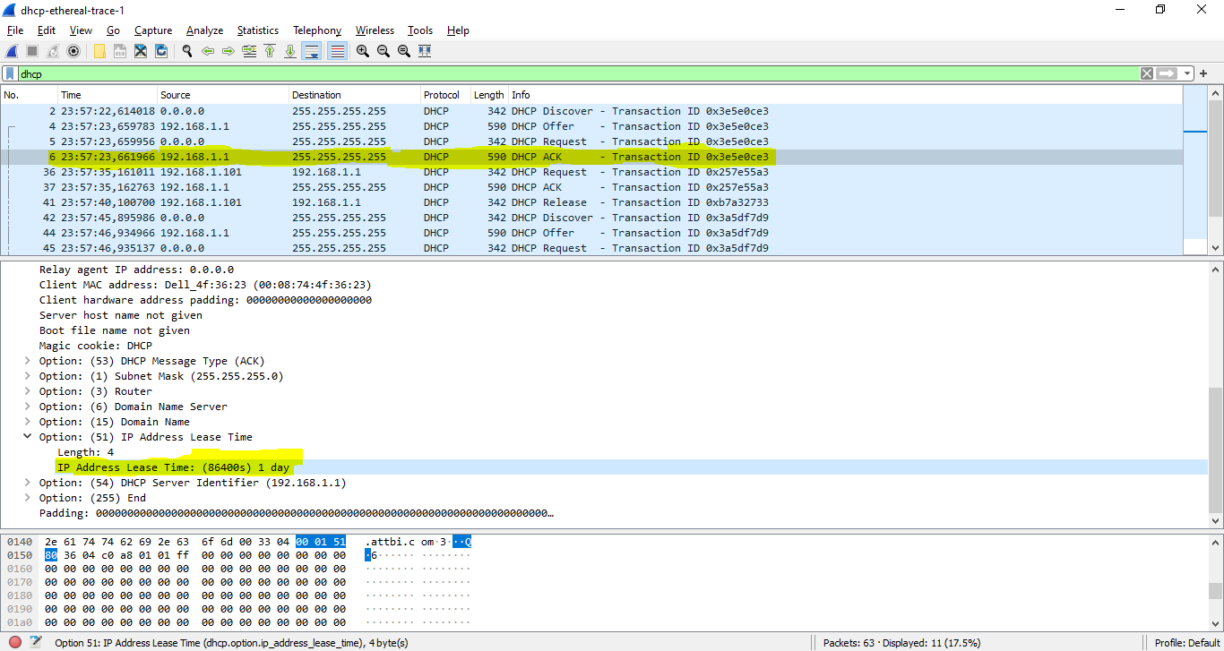

**Question 13**: What is the purpose of the DHCP release message? Does the DHCP server issue an acknowledgment of receipt of the client’s DHCP request? What would happen if the client’s DHCP release message is lost?

**ANSWER:**

The purpose of the release message is to release the IP address back to the server.

The DHCP server does not send a message back to the client acknowledging the DHCP Release message.

If the message is lost, the client releases the IP address, but the server will not reassign that address until the clients lease on the address expires.

**Question 14:** Clear the bootp filter from your Wireshark window. Were any ARP packets sent or received during the DHCP packet-exchange period? If so, explain the purpose of those ARP packets.

**ANSWER:**

Yes, there are ARP requests made by the DHCP server.

Before offering an IP address to a client, the DHCP server issues an ARP request for the offered IP

=> Make sure the IP address is not already in use by another workstation

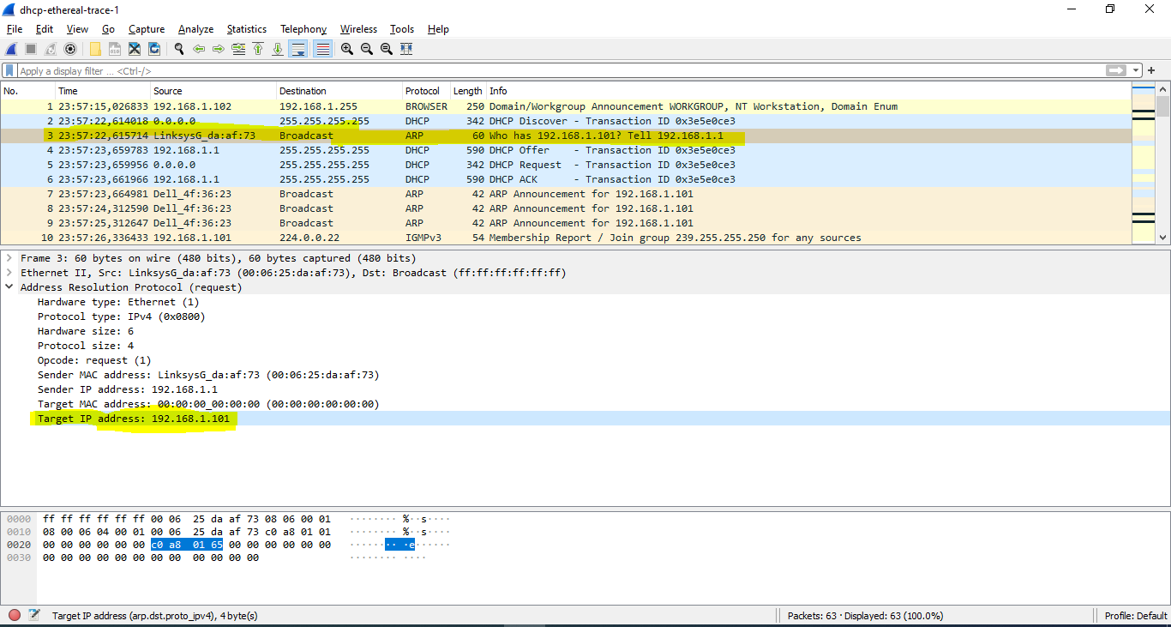

**The capture of terminal:**

